SIMATS ENGINEERING (SAVEETHA SCHOOL OF ENGINEERING)
Department of Artificial Intelligence and Machine Learning
ASSESSMENT TOOL 3 – Analytical Problem Solving (5 QUESTIONS)

Course Code: | MLA0407 | Course Title: | Deep Learning  Assessment Tool 3 – Experiments  (5 Questions × 10 Marks)
CO Assessed: | CO1 | Assessment:
Weightage: | 35% of CIA | Total Marks:
CO1 Statement: | Apply the fundamental concepts of machine learning and neural networks to design and analyze learning algorithms using perceptrons, multilayer perceptrons, forward propagation, backpropagation, gradient descent optimization techniques, and Maximum Likelihood Estimation for solving real-world problems.
Student Name: | A.Siva suraj sai | Reg. No.: | 192425276
Section / Batch: | AIML | Date:

Code of Conduct
I CH. Durga Prasad certify that this submission is my original work and that I have adhered to the guidelines specified for this assessment. I understand that any violation of academic integrity rules

Name: - A.Siva suraj sai Course code: - MLA0407
Reg no: - 192425276 Course Name: - Deep Learning Experiment 1: Implementation of a Single Artificial Neuron Objective: Implement a single artificial neuron using Python. Task: Total Marks: 50 Annexure A Experiments Aim
To implement a single artificial neuron using Python that accepts multiple inputs, computes the weighted sum, applies a step activation function, and generates the output.
Algorithm
- Start.
- Define input values.
- Define weights and bias.
- Calculate weighted sum.
- Apply step activation function.
- Display output.
- Stop.
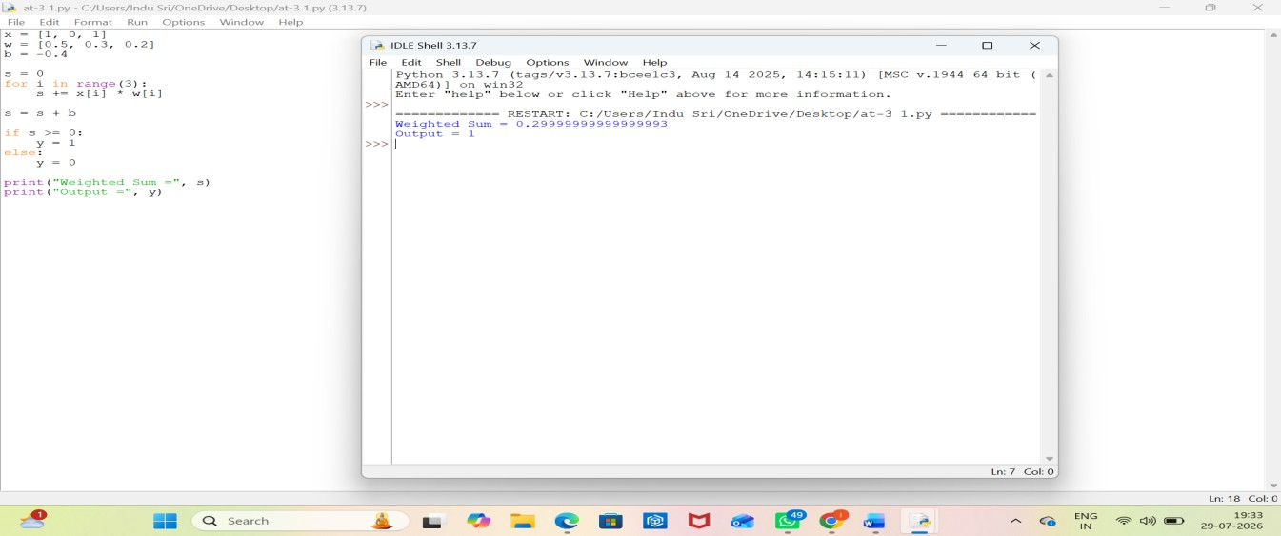

Result: -
The artificial neuron successfully computed the weighted sum and produced the correct binary output using the step activation function.
Experiment 2: Perceptron for AND Gate Objective: Implement the Perceptron Learning Algorithm. Task:
Aim
To implement the Perceptron Learning Algorithm for the AND logic gate.
Algorithm
- Start.
- Define AND gate inputs and outputs.
- Initialize weights and bias.
- Train the perceptron.
- Update weights using the perceptron rule.
- Display final weights and predictions.
- Stop.
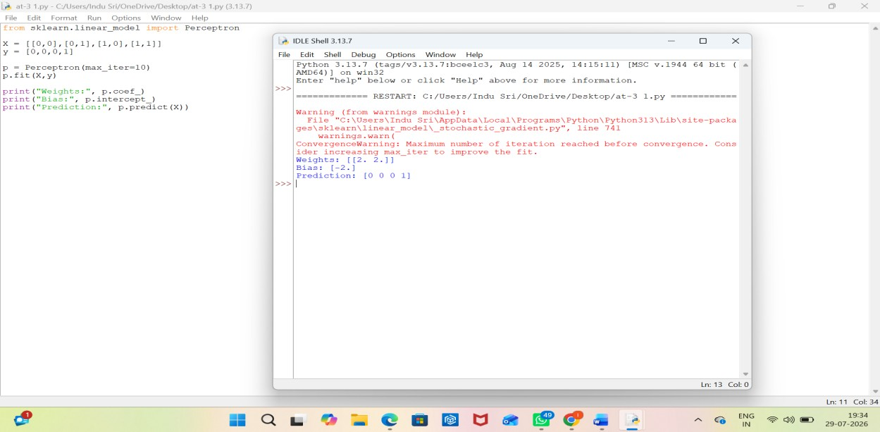

Result: -
The perceptron correctly classified the AND gate with 100% accuracy.

Experiment 3: Perceptron for OR Gate Objective: Design a perceptron model for binary classification. Task: Implement a perceptron to classify the OR logic gate. Aim
To implement a perceptron model for the OR logic gate.
Algorithm
- Start.
- Define OR gate inputs and outputs.
- Initialize weights and bias.
- Train the perceptron.
- Predict outputs.
- Display weights and predictions.
- Stop.
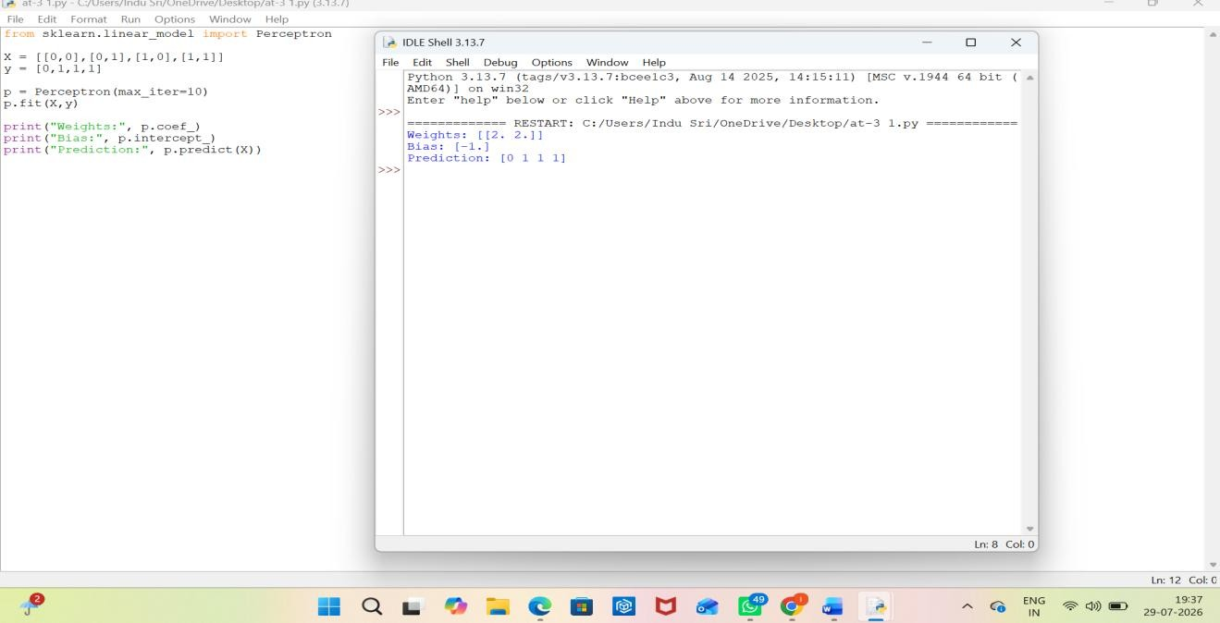

Result: -
The perceptron correctly classified the OR gate with 100% accuracy.
Experiment 4: XOR Classification Analysis Objective: Study the limitations of a singlelayer perceptron. Task: Attempt to train a perceptron for the XOR logic gate. Aim
To study the limitations of a single-layer perceptron using the XOR logic gate.
Algorithm
- Start.
- Define XOR inputs and outputs.
- Train a perceptron.
- Predict outputs.
- Observe incorrect classification.
- Conclude that XOR is not linearly separable.
- Stop.
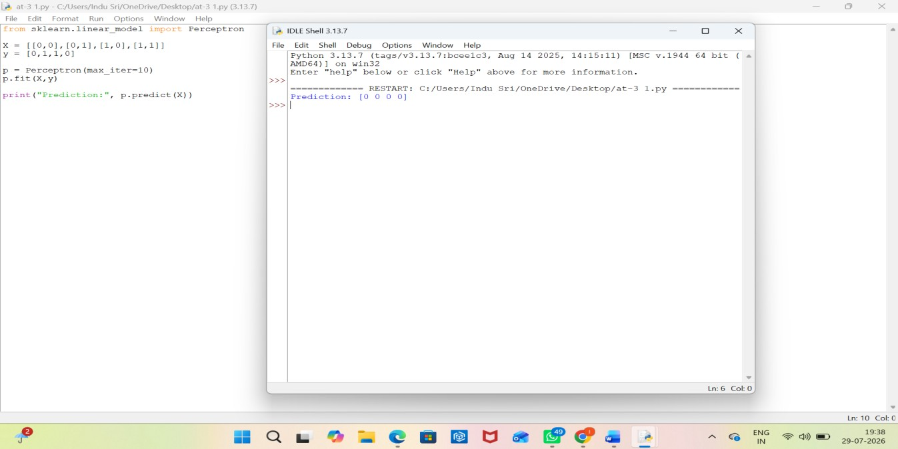

Result: -
The single-layer perceptron failed to classify the XOR gate because it is not linearly separable.

Experiment 5: Gradient Descent Optimization Objective: Understand Gradient Descent. Task: Implement the Gradient Descent algorithm to minimize a simple quadratic cost
function.
Aim
To implement the Gradient Descent algorithm for minimizing a quadratic cost function.
Algorithm
- Start.
- Initialize learning rate and parameter.
- Compute gradient.
- Update parameter using Gradient Descent.
- Repeat until convergence.
- Plot cost versus iterations.
- Stop.
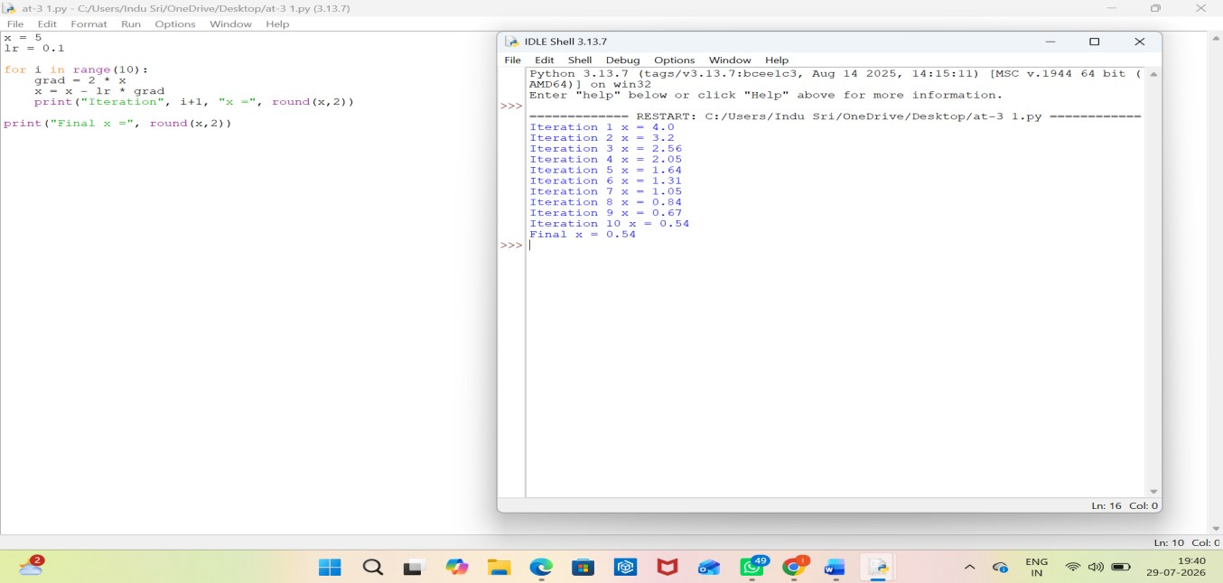

Result: -
Gradient Descent successfully minimized the cost function, showing convergence over the iterations.
Rubrics for Calculation

Criteria | Weightage | Level 4  (Exemplary) | Level 3 (Proficient) | Level 2 (Developing) | Level 1 (Beginnin  g)
Technical Content  Accuracy | 30 | Highly accurate,  indepth, and insightful technical explanation | Technically correct  content with adequate  depth and clarity | Basic concepts  presented  with limited  accuracy and depth | Content contains major  technical errors;  concepts poorly understood
Problem  Identification | 25 | Problem rigorously  analyzed using  appropriate and advanced methods | Problem clearly defined with a logical  engineering approach | Problem  identified but analysis or  methodology  is  weak | Problem statement unclear or  incorrect;  no  logical approach
Use of Tools | 20 | Advanced tools, well-analyzed  data, and highly effective visuals | Appropriate tools and  data used effectively with clear visuals | Limited use of tools and basic data interpretation | Minimal or incorrect use of tools and  data; poor  visuals
Communicatio n | 15 | Highly engaging,  confident, and audiencefocused delivery | Clear, organized, and  professional communication | Understandable but lacks clarity, structure, or confidence | Poor  organization, unclear  speech,  ineffective slides
Professionalis m | 10 | Exemplary professionalism  , leadership, and ethical awareness | Professiona l conduct with  effective team  collaboratio n | Basic professionalis  m; uneven team  participation | Lacks professionalis m; minimal  contribution or ethical  awareness

Faculty In-charge | Course Coordinator | Program Director
Signature: | Signature: | Signature:
Date: | Date: | Date:

